1.2 Volumes Worksheet

- Let R be the finite region bounded by the graphs of .

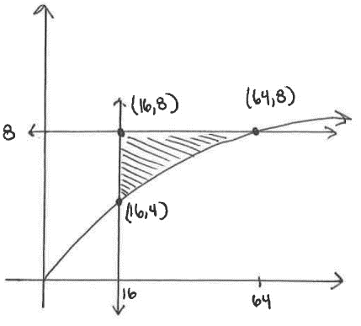
We first sketch a picture of the region.
We see that the curves intersect when:
Therefore, the point of intersection is

- Determine the volume of the solid formed when R is revolved around the line .

We see that we have cross sections which are disks stacking up in the x-direction. Therefore, we have:

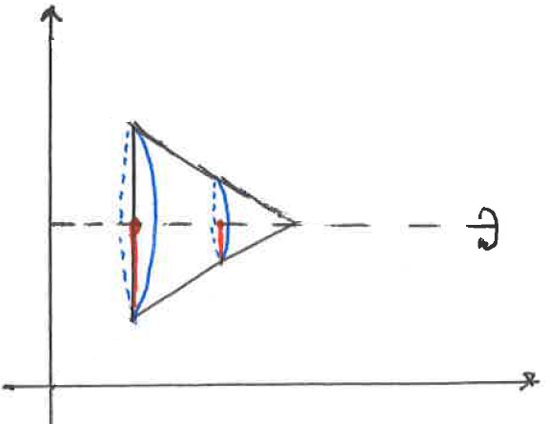

- Setup, but do not evaluate, a definite integral which represents the volume of the solid formed when R is revolved around the line .

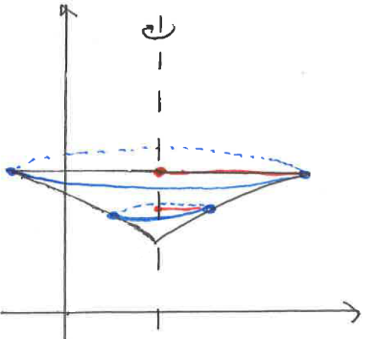
We see that we have cross sections which are disks stacking up in the y-direction. We must solve our equations for x. We get:

Therefore, we have:

- Setup, but do not evaluate, a definite integral which represents the volume of the solid formed when R is revolved around the line .
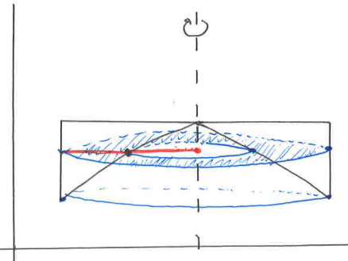

We see that we have cross sections which are washers stacking up vertically. We must solve our equations for x. We get:

Therefore, we have:

- The graphs of , , and the y-axis bound a region R in the xy-plane. Setup, but do not evaluate, a definite integral which represents the volume of solid obtained when R is revolved the line .
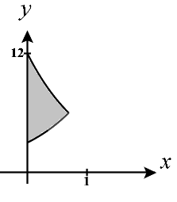
We draw a picture of the region (shown at the right). We see that these curves intersect when:
Therefore, the point of intersection is

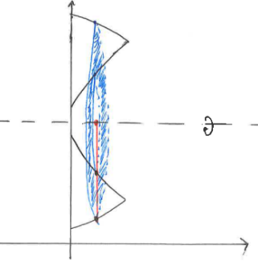
We see that we have cross sections which are washers stacking up horizontally. Therefore, we get:

- Let R be the finite region bounded by the graphs of , , and . Set up, but do not evaluate, definite integrals which represent the volumes of the following solids.

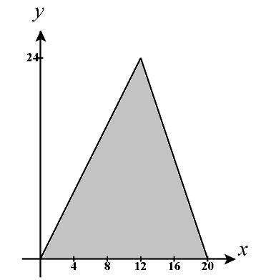
We draw a picture of the region (shown at the right). We see that these curves intersect when:
Therefore, the point of intersection is

- The volume of the solid formed when R is revolved around the line .

We see that we have cross sections which are washers stacking up vertically. We must solve our equations for x. We get:
and

Therefore, we have:

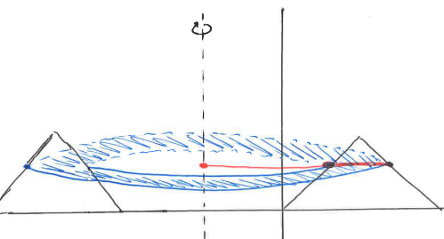

- The volume of the solid formed when R is rotated around the line .

We see that we have cross sections which are washers stacking up horizontally. However, we see that the functions which help us determine radii of these washers change at the point of intersection, so we need two integrals to find this volume. Therefore, we get:

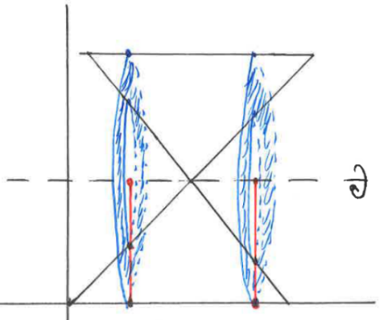

- The volume of the solid with base R for which the cross-sections perpendicular to the y-axis are squares.

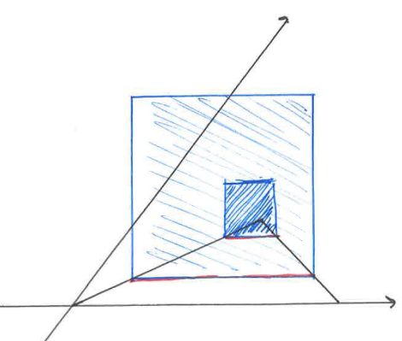
We have cross sections which are squares stacking vertically. We must solve our equations for x. We get:
and

We see that the side length of a square is given by , therefore we have:

- Let R be the finite region bounded by the graphs of , , and . Set up, but do not evaluate, definite integrals which represent the volumes of the following solids.
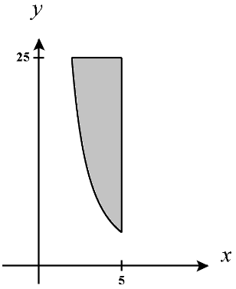

We draw a picture of the region (shown at the right). We see that the curves and intersect when:
Therefore, the point of intersection is .

- The volume of the solid formed when R is revolved around the line .

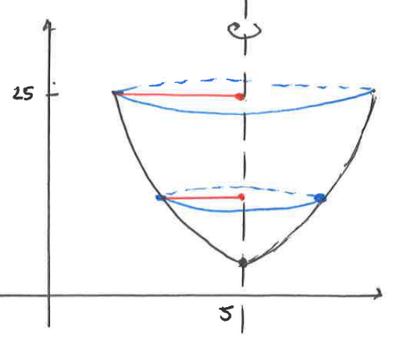
We have cross sections which are disks stacking vertically. We must solve our equations for x. We get:

Therefore, we have that:
- The volume of the solid formed when R is revolved around the line .

We have cross sections which are disks stacking vertically. We must solve our equations for x. We get:
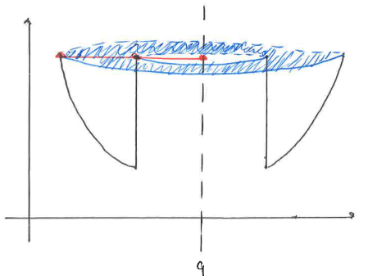
Therefore, we have that:

- The volume of the solid with base R for which the cross-sections perpendicular to the x-axis are equilateral triangles. Hint: If S represents the length of each side in an equilateral triangle then its area is equal to squares.

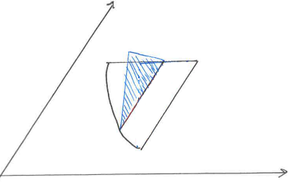
Our cross sections are equilateral triangles which stack up horizontally. The base side of the triangle is given by:

Therefore, using the formula provided in the question we have that:

- Let R be the finite region bounded by the graphs and . Set up, but do not evaluate, definite integrals which represent the volumes of the following solids.
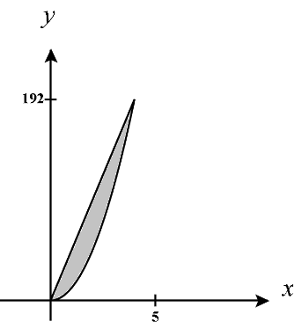
We draw a picture of the region (shown at the right). We see that the curves and intersect when:
Therefore, the points of intersection are and .

- The volume of the solid formed when R is revolved around the line .
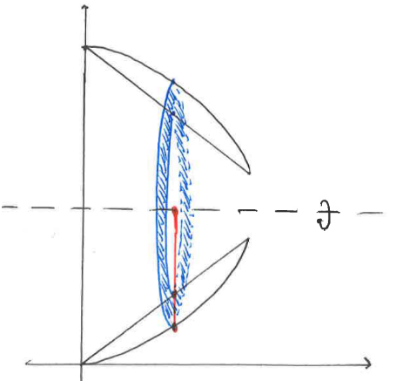
We have cross section which are washers stacking up horizontally. Therefore, we get:

- The volume of the solid whose base is R for which cross-sections parallel to the x-axis are semicircles.

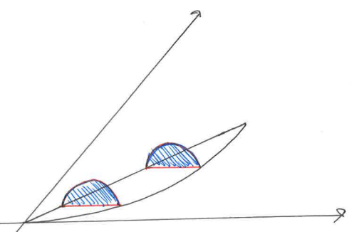
We have cross sections which are half circles stacking up vertically.
We must solve our equations for x. We get:
and
We see that the diameter of each circle is given by and so the radius of each circle is given by .

Therefore, we get:

- Let R be the finite region bounded by the functions . Set up, but do not evaluate, definite integrals which represent the volumes of the following solids.

We draw a picture of the region (shown at the right).
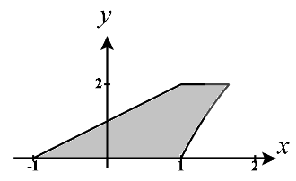
We see that the curves intersect when:
. Therefore, the point of intersection is .
The remaining intersections of these curves is easy to deduce from the picture and the curves.

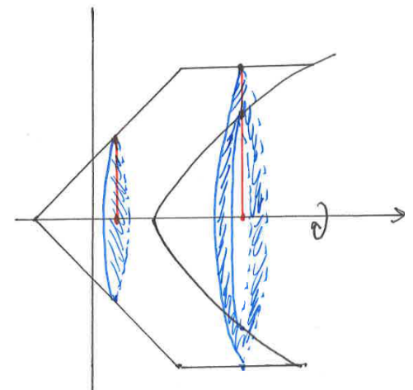
- The volume of the solid formed when R is revolved around the x-axis.

We see the cross sections are disks on and washers on which both stack horizontally. Since we have different cross sections used in the creation of this solid we will need multiple integrals to determine this volume.

- The volume of the solid formed when R is revolved around the line .

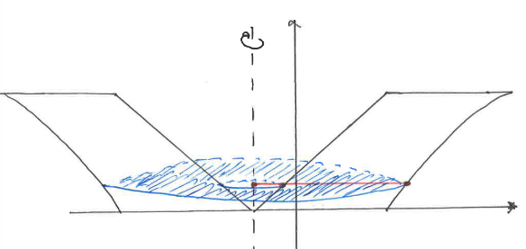
We see cross sections which are washers stacking vertically. Therefore, we must solve our equations for x. We get:
&

So we get:

